JOHC, x(x): xxx-xxx, Nov 202x ISSN: xxx-x-xx-xxxx-x
Websites: http://johc.umla.ac.id/index.html
DOI:xxxxxxxxxx

IMPLEMENTATION OF MANAGEMENT INFORMATION SYSTEM
COMPUTER BASED ON HOSPITAL MANAGEMENT
ON PATIENT SATISFACTION AT PKU KARANGASEM MUHAMMADIYAH HEALTH CENTER, PACIRAN LAMONGAN

Suyitno ¹ , Yulie Wahyuningsih
- Lecturer of S1 Management Study Program, University of Muhammadiyah Lamongan
- Lecturer of S1 Management Study Program, University of Muhammadiyah Lamongan
Email: yitnomasdar@gmail.com

Abstract

This study aims to determine the implementation of a computer-based management information system in hospital management on patient satisfaction at the PKU Karangasem Muhammadiyah Paciran Lamongan Health Center.

PKU Karangasem Muhammadiyah Paciran Lamongan health center has implemented a computer-based management information system in order to realize its vision and mission and to improve the quality of both services and facilities. The implementation of the SIM itself is applied to the management of existing data from incoming patients to outgoing patients. In the input sub-system as input data, all incoming data starts from the registration unit as the beginning of patient registration, both new patients and old patients. As a unit that carries out the function of registration or patient registration, the registration unit is responsible for the data collection process, which in this case is the data of patients who will seek treatment. While in the transformation sub-system, all incoming data, namely every transaction made by the patient is processed and processed through a computerized system which is then collected and stored in a database to be made a report as an output form to be submitted to the parties who need it.
In the application of a computer-based management information system, PKU Karangasem Muhammadiyah Paciran Health Center has been supported by components in the form of hardware and software, human resources, data, and procedures, all of which run continuously and support. To facilitate the application of SIM PKU Karangasem Muhammadiyah Paciran Health Center, it is also equipped with a LAN (Local Area Network) network with Microsoft Excel software and Microsoft Access with visual basic programs. With the LAN network, data that has entered the server will be more easily accessible for users who need it.
From the results of the study using a questionnaire on patients and officers of the PKU Karangasem Muhammadiyah Paciran Health Center, it is known that the influence of the relationship between the application of a computer-based management information system is low according to the results of the calculation with a product moment correlation of 0.277. This is because there are still many workers who have not been able to optimize computer-based management information systems so that it affects the service to their patients.

Keywords : Management Information System, Management and Customer Satisfaction

PRELIMINARY

Referring to law number 44 of 2009 article 52 paragraph 1 that every hospital is obliged to record and report all hospital operations in the form of a hospital management information system. Facing the era of globalization requires the health sector, especially hospitals, to increase competitiveness by providing the best service to customers or patients, even in presenting accurate reports for decision makers. In line with the development of the world of technology, every institution or company is required to include systems, especially information systems as part of the management of the institution or company concerned, because the inclusion of information systems in each institution or company is expected to increase competitiveness with other institutions or companies, because With the information system all related information will be easily and quickly accessed for those who need it. In addition, the information system can be used as an evaluation material for policy makers to make the right decisions so that errors can be minimized.
Long before the advent of computer technology, management information systems (MIS) have been used by organizational or company leaders in decision-making efforts.
However, the decision-making process carried out at that time was very simple, everything was still running manually because all data was still stored in various archive sheets. Where if the leader needs a variety of information in the archives to be used for decision making, it is very difficult to find it. Storage of these files is very ineffective, so it takes a long time to find them. In addition, the possibility of the ineffectiveness of the storage method makes some of the archives that have been stored damaged or not maintained. The search process at that time where computer technology had not been found. With the advent of computer technology in this day and age, it has changed everything. Various archives and documents that were previously stored manually are now all stored digitally.
Information systems and technology have become very important components for the success of businesses and organizations. Information technology, including Internet-based information systems (computers), is playing an important and increasingly widespread role in business. Information technology can help businesses of all types improve the efficiency and effectiveness of their business processes, managerial decision making, and teamwork, thereby strengthening their competitive position in a rapidly changing market.
Management Information System Information can be likened to the blood that flows in the human body, as well as information in a company which is very important to support its continued development, so there is a reason that information is needed for a company. As a result, if you do not get information, at a certain time the company will experience an inability to control resources, so that in making strategic decisions it is very disturbed, which in the end will experience defeat in competing with its competitors.
Computers are useful for data processing tasks but a management information system performs other tasks and is more than just a data processing system. Managers always use information to carry out their tasks, so the subject of information management is not something new. What is new is the ease of obtaining accurate and up-to-date information. The innovation that makes this capability possible is the electronic computer. Organizations are becoming increasingly aware that information is a strategically important resource, and computers can process these resources as used in the PKU Karangasem Muhammadiyah Paciran Lamongan Health Center.

RESEARCH METHODS
This type of research is descriptive using qualitative methods. The population in this study is the entire management information system used in data management at the PKU Karangasem Muhammadiyah Paciran hospital, while the samples in this study are patients and employees who will be respondents to determine the level of patient satisfaction with a computer-based management information system for management. hospital. The variables in this study are Management Information Systems and Patient Satisfaction which is a feeling of pleasure, individual satisfaction because of the fulfillment of expectations or desires in receiving health services. Collecting data using closed questionnaire sheets, interviews and observations, while data processing uses editing, coding, tabulation of temporary conclusions, triangulation and final conclusions.

RESULTS AND DISCUSSION

Research result
1.General Data
- Number of PKU Muhammadiyah Karangasem Paciran Workers
Table 4.1. Number of Workers at PKU Muhammadiyah Karangasem Paciran.

No | Power type | Full timer | Part timer
1 | Medical personnel  - Number of general practitioners  - Number of specialist doctors  - Total number of doctors | 4 people  0 people  4 people | 0 people  10 people  10 people
2. | paramedic staff  - Number of nursing paramedics  - Number of midwives  - Number of non-nursing paramedics  - Total number of paramedics | 19 people  4 people  4 people  27 people | 0 people  0 people  0 people  0 people
3. | Non-medical personnel  - Pharmacist  - Other Bachelors  - Etc  - Total number of medical personnel | - person  - person  29 people  35 people | 0 people  0 people  0 people  0 people
 | Total power | 66 people | 10 people

- LAN network flowchart (Local area network)
Figure 4.1. LAN network flow chart at PKU Muhammadiyah Karangasem Paciran.

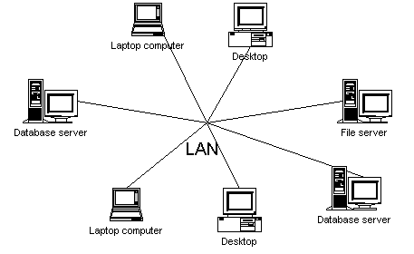

Based on the picture above, PKU Muhammadiyah Karangasem Paciran uses a LAN network, because it has a very fast data transmission speed because it does not depend on networks such as networks on cellular phones, so that every time it processes data, the data can be directly distributed to each computer. which is available.

2. Special Data
1). Patient Registration Form
Figure 4.3. Patient Registration Form at PKU Muhammadiyah Karangasem Paciran

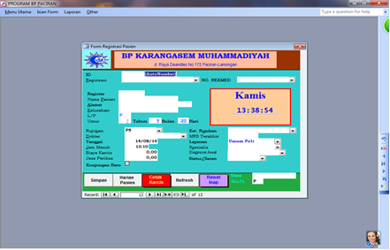

Based on the picture above, it explains the registration flow at the registration unit (patient registration), the patient's identity is recorded on the card or medical record status for further processing, and then the patient and his card or medical record status are brought to the examination room (Medical Record).

2). Observation Care Recap Form
Figure 4.4. Observation Care Recap Form at PKU Muhammadiyah Karangasem Paciran

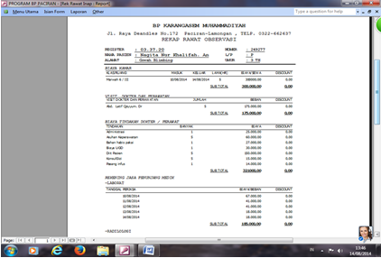
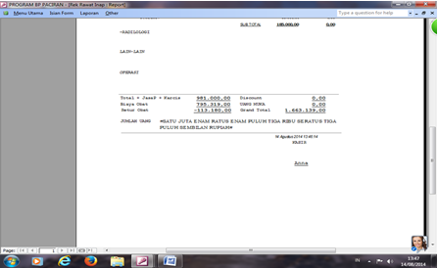

Based on the picture above, it explains that all health services are recorded in the card or medical record status. Every health worker who performs health services and or medical actions must write his name and put his signature on the card or medical record status. After going through the above process, the patient can take care of the administrative costs at the financial unit, and then the patient is allowed to go home.

3). Patient Receipt Form
Figure 4.5. Patient Receipt Form at PKU Muhammadiyah Karangasem Paciran

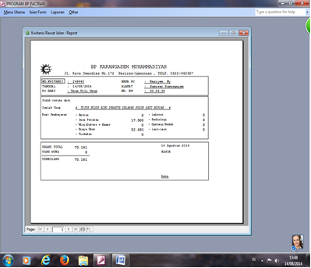

Based on the picture above, it is proof of receipt for the patient to pay off the costs incurred while in treatment at PKU Muhammadiyah Karangasem Paciran which is printed digitally.

4 ). Correlation Test
Table 4.4. Correlation Test Results

Correlatons
 |  | SIM |  | Kep_Pas
SIM | Pearson Correlation | 1 |  | 0.277
SIM | Sig. (2-tailed)  N | 30 |  | 0.139  30
Kep_Pas | Pearson Correlation  Sig. (2-tailed)  N | 0.277  0.139  30 |  | 1  30

Based on the table above, it is known that the correlation value between the questionnaire values regarding the application of computer-based management information systems and the patient satisfaction level questionnaire value is 0.277, which means that the correlation value is low .

Discussion

Based on table 4.1, it can be seen that the general number who work full time is 4 people, while specialist doctors who work part time are 10 people. There are 19 nursing paramedics who work full time, 4 midwives who work full time and 4 non-paramedic staff who work full time. The non-paramedical staff who work full time are 1 pharmacist, 4 other graduates and 29 others. So that the total number of workers who work full time is 66 people and those who work part time are 10 people.
Based on Figure 4.1, it can be seen that the PKU Karangasem Muhammadiyah Health Center implements a computer-based management information system using a LAN (Local Area Network) network application as its server. Which LAN is a connecting system that allows a source to be used simultaneously even though in a different place and time, with a LAN (Local area network) each hospital functional unit can easily access the files needed from other functional units. LAN is a Network where the connection that occurs is only limited to one location, for example in a building complex. The connecting media used is usually a cable. The LAN network is used at the PKU Karangasem Muhammadiyah Paciran Health Center because it has a very fast data transmission speed because it does not depend on networks such as networks on cellular phones, so that every time you do data processing, the data can be directly distributed to each available computer.
Based on Figure 4.3, it is known that the initial stage of the health service process flow at the PKU Karangasem Muhammadiyah Paciran Health Center is starting from the registration unit or patient registration. At the registration unit (patient registration), the patient's identity is recorded on the card or medical record status for further processing, and then the patient and his card or medical record status are brought to the examination room (Medical Record). By health workers, the patient is examined, and if necessary, examination treatment or supporting units including Laboratory, Radiology. Finally, the diagnosis will be enforced and as needed, the patient is given medicine or redeems his own medicine at the pharmacy.
Based on Figure 4.4. It is known that the PKU Karangasem Muhammadiyah Paciran health center has 10 computers, in the cashier unit there is 1 computer, in the nursing unit there is 1 computer, in the pharmacy there is 1 computer, in the laboratory unit there is 1 computer, on the 3rd floor office unit. there are 4 computers and in the 2nd floor office there are 2 computers, each of which has a different function. In the process of data storage, administrative data in the medical record unit is in the form of archives or documents and also in the form of files stored on a computer, where the data contains the patient's disease history. Then in data storage, each patient data record that is made will be stored in the database of each computer according to its function, namely the data or document storage function and the data function which will then be made a report. In entering each of these databases into the computer, or each processing, each officer on duty in the unit has a password to log in or enter the server or network, so that the name of the officer can be known when recording or recording data input in the data input process. It is intended that the officer who fills in this is responsible if there is an error in writing or filling in the data processing process.
Based on Figure 4.5, it is known that the receipt for the patient to pay the costs incurred while in treatment at PKU Muhammadiyah Karangasem Paciran is printed digitally. and for data storage media, besides being stored in a computer terminal equipped with a CPU, it is also automatically backed up on the server computer or the main computer, namely on a hard disk that has a storage capacity of up to hundreds of Giga Bytes (GB), so there is no need for data backup. secondary storage such as flash disk or CD (Compact Disk). Here it can be said that the data that goes to the main computer (server) which in this case the medical record unit is stored and managed properly, because when the data is needed then the data can be accessed easily. The medical record unit (server) can carry out its functions properly, meaning that if at any time another health service unit requires data, then the data can be accessed and just enter the required data. As for based on table 4.4. it is known that the correlation value between the questionnaire value on the application of computer-based management information systems with the patient satisfaction level questionnaire value is 0.277, which means that the correlation value is low. This is because there are still many workers who are not optimal in operating computer-based management information systems in data processing. This is proven by the existence of services that still use the manual system, namely in making referral letters for general patients and BPJS patients, and also in payment systems that do not use the banking system.

CONCLUSION

That the application of a computer-based management information system at the PKU Karangasem Muhammadiyah Paciran Health Center has been supported by the presence of components in the form of hardware and software, human resources, data, and procedures all of which run continuously and support. To facilitate the application of SIM PKU Karangasem Muhammadiyah Paciran Health Center, it is also equipped with a LAN (Local Area Network) network with Microsoft Excel software and Microsoft Access with visual basic programs. With the LAN network, data that has entered the server will be more easily accessible for users who need it. Meanwhile, the influence of the relationship between the application of a computer-based management information system is low according to the results of the calculation with a product moment correlation of 0.277. This is because there are still many workers who have not been able to optimize the computer - based management information system so that it affects the service to their patients .

BIBLIOGRAPHY

Aini, A. 2007. Geographic Information Systems Definition and Applications . STMIK AMIKOM. Yogyakarta.
Ardian Agung Y., et al. 2009. Analysis and Design of Information Systems . Telkom Polytechnic 2. Bandung
Fajrin, D. 2008. Effect of Computer-Based Management Information System (MIS) on Employee Performance at PT Golden Gate Mandiri (Doctoral dissertation, Widyatama University).
Htpp://www.tugasku4U.com, Paper on Management Information systems , 17 june 2014, 11:13 am
Manullang, M. 2000. Introduction to Business . Gadjah Mada University Press, Yogyakarta
McLeod, R.jr. 1995. Management Information Systems . Indonesian Edition Volume I. PT. Prenhallindo. Jakarta
McLeod, R.jr. 2008 . Management Information System . Indonesian Edition Volume 10. Salemba Empat. Jakarta
Muhammad, M., & Nurdyansyah, N. 2015. Scientific Learning Approach. Sidoarjo: Nizamia learning center.
Nujumia, C A. 2010. Basic Concept Paper of Information Systems .
Nurdyansyah, N. 2017. Resources in Educational Technology . Muhammadiyah University of Sidoarjo.
Nurdyasnyah, N., & Andiek, W. 2015. Innovation in learning technology. Sidoarjo: Nizamia learning center.
Nurdyasnyah, N., & Andiek, W. 2017. ICT-Based School Management . Sidoarjo: Nizamia learning center.
Sadono Sukirno, 2006, Wan Sabri Husen., Danny Indrianto., Charles Sianturi., Kurniawan Saefullah, Business Reviewer , Jakarta: Kencana.
Sidh, R. 2013. The Role of Brainware in Management Information Systems. Journal of Computech & Business , Jakarta.

